**Project: Weatherford Configuration Manager**

**Description:**

* Configuration tool used for configuring the common platform devices (Remote Terminal Unit) by monitoring the firmware.
* This tool reduces the work of the user in controlling the common platform devices.
* The User need not memorize the values.
* Configuration can be done online/offline

**Client Requirements:**

* Firmware details for various configurations need to be loaded to the database.
* Data related to configurations are converted to xml format for easy user understanding and interaction.
* The Xml file for a particular configuration will be loaded to the WCM.
* User can configure/Change the values of various applications and the changes can be stored either locally or it can be moved to the hardware (memory card).

**Work done:**

* Created the UI with a good look and feel using WPF (Infragistics API added for improving the look and feel). The below figure is a sample for outlook kind of look and feel.

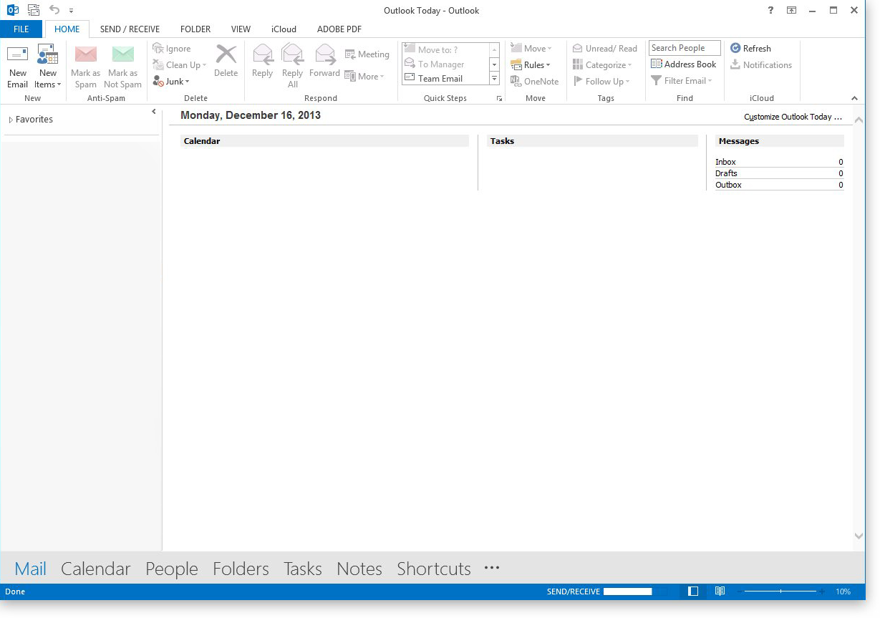

* Performance improvement of the application.

***Identified problem***:

Found the performance issue, while loading large xml files in an application. Here the xml data is very big and when we try to load thousands of xml pages it took around 2 hours to load the complete data. This will stop the user to work further for a very long time.

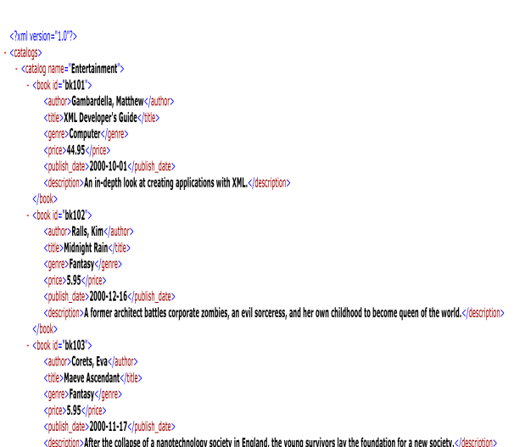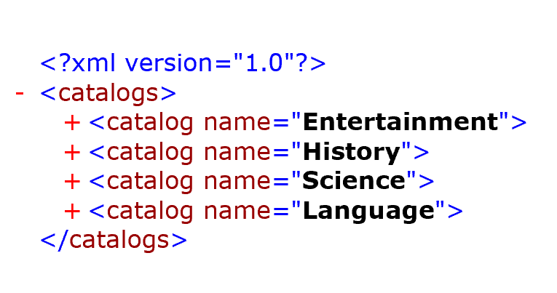***Proposed solution*:**

After

Before Implementation

Instead of loading the entire Xml file I gave a new proposal for loading only the top level parent and it will be shown to the user. When the user wants to see the details of an element then he has to click on it, the details of that particular element will be loaded.

**Achievement:**

* After implementing the proposal there was a improvement in the performance by 150 %
* The time take for loading the file reduce from 2 hours to less than 1 minute.
* Appreciated by the client for giving the huge performance benefit.
* Implemented Upgrade firmware by sending the upgrade files from the application to the hardware. The connection between WCM and the hardware is established by TCP/IP connection (Socket Programming) and the files are transferred through FTP protocol.

1. First validate the upgrade file.
2. Establish connection with the hardware
3. Take a backup of the existing file in memory card for use in case of upgrade failure.
4. Transfer the file and start the upgrade.

***Challenge faced:***

While taking backup if there is not enough space in the memory card, the upgrade will be discarded. But the client wanted to send the upgrade file to the application location.

***Solution*:**

This requires establishing and closing connection 3 times in the worst case, which is a costly and tedious operation. This was clearly explained to the client and the final decision was made to stop the upgrade in such case and check for the memory card size and do the necessary action before starting the upgrade.

The time allocated for implementing all these was also not sufficient, because there was lot of validations and testing to be done. Explained the problem programmatically to the client and extended the deadline for this implementation.

***Achievement:***

Appreciated by the client for doing all the validation and providing various test scenarios for the testing team to reduce their effort.

* Used IoComp for plotting Graphs.
* Designed the UI for fetching the current time of the device and setting the time.
* Different layers used in this layer are UI Layer/Presentation Layer, Application Layer, Business Logic Layer, Operations/Transportation Layer.
* Done code analysis for checking whether the application follows Microsoft and Infosys coding standards or not.
* Integrated the code using perforce integration tool on a daily basis.

**Project: DTLLabQ**

**Description:**

* This is the web application used by the customer for maintaining the data about various products, tests to be performed, person in charge for the test and the test results.
* I was a member of the team responsible for developing application which is especially used for Iron testing.

**Work done:**

* Designed the smart device application for Scanning RFID and the data entry will be made in the database.
* 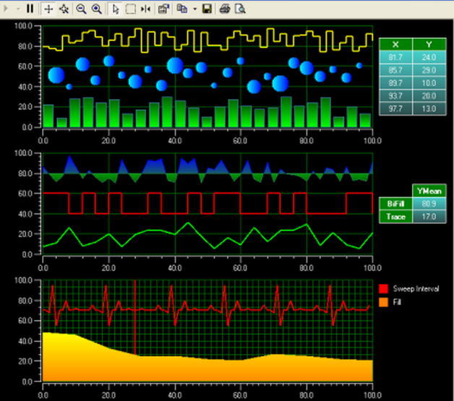Data will be stored in the SQL Server database. Connection was established with the database, stored procedures, functions and SQL queries are written for fetching data and that will be displayed in the UI. The user will select the Iron and send it for testing to the person based on availability. The person will receive a mail about the testing to be done. On completion of testing he will enter the test results in the application which will be updated in the corresponding table.
* Designed the UI pages using AJAX controls for asynchronous page loading.
* Automated power point generation which will show the graphs of various test results by fetching data from the database using web services.
* Used TFS for integrating the project.

sample graph using IoComp

**Achievement:**

Appreciated by the client for successfully integrating the iron testing with the testing application.